**COEIT Advising Website - Database Setup**

The new version of the website maintains largely the same Database setup as the original- the only addition to the database is the **MeetingRoom** column in the **Proj2Advisors** table.

Please use the following MySQL command to add the MeetingRoom column to the old database:

|  |
| --- |
| ALTER TABLE `Proj2Advisors` ADD `MeetingRoom` VARCHAR( 100 ) NOT NULL ; |

Alternatively, setting up the database from scratch can also be done immediately with the MySQL commands in **DataBase-Setup-Command.txt**, which is located within the resources folder of this package.  
This may be more convenient, but transferring old data from the previous database may be somewhat of a hassle.

**[Proj2Advisors table]**

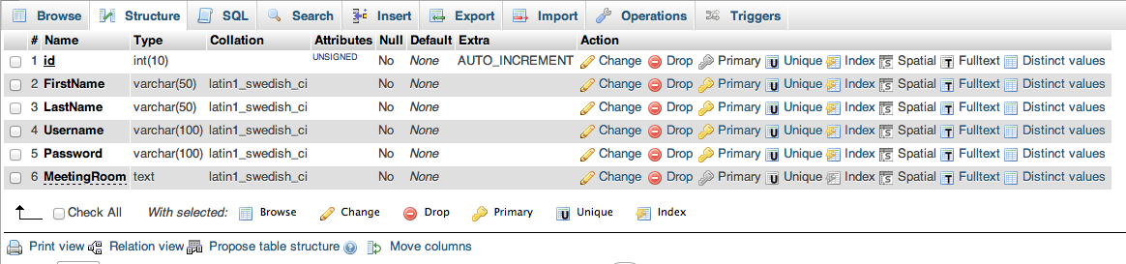

(table structure ^)

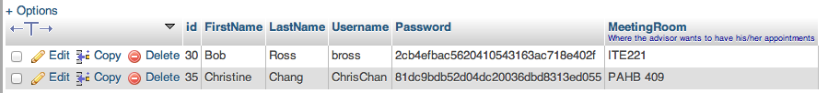

(Example advisors ^)

-Advisors are identified by their unique **id** and **username**.  
**-Password** and **MeetingRoom** values can be changed by the advisor through the website’s interface, but their name(s) and username cannot be edited for the sake of consistency.  
-The Password value goes through a hashing process in order to protect it, and thus appears like gibberish on the database side.

**[Proj2Appointments table]**

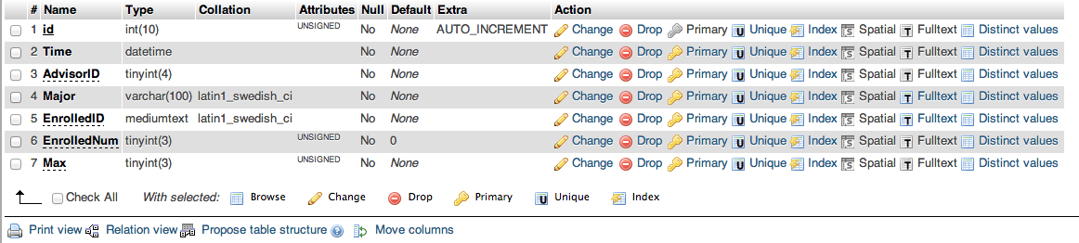

(table structure ^)

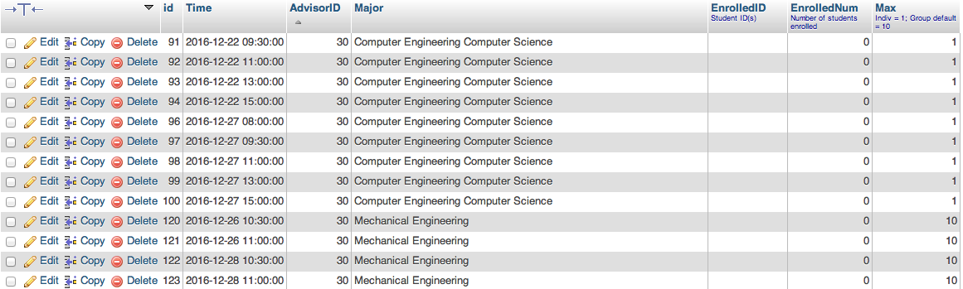

(Example appointments ^)

- Appointments are identified by their unique **id**.  
- The **Time** value contains the date and time of the appointment.  
- The **AdvisorID** value corresponds with the unique id of the advisor who set up the appointment. Due to the way the website was updated, Group meetings now have a specific advisor (and AdvisorId) who initially created it, as opposed to the value 0 in the previous version.  
- The **Major** value lists the majors that can enroll into an appointment.  
- The **EnrolledID** value contains the student IDs of the students enrolled in the appointment.   
In the case of an individual appointment, there will only be one.   
In the case of a group appointment, there may be multiple student IDs listed.  
- The **EnrolledNum** corresponds with the number of students enrolled in an appointment. **-** The **Max** value determines how many students can enroll in an appointment.  
Individual appointments always have a max value of 1.  
Group appointments are assigned a max value of 10 as default, but can be edited from the Advisor side of the website to increase or decrease the number.

[Proj2Students table setup]

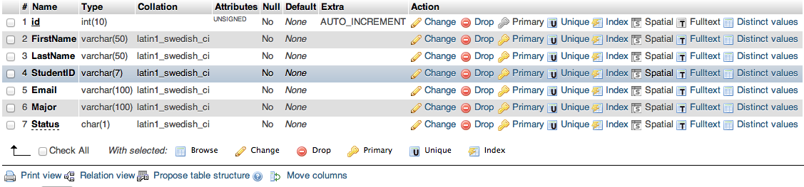  
(table structure ^)

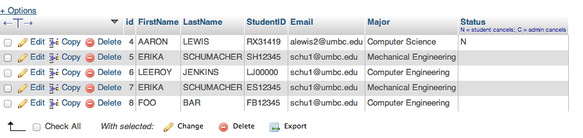  
(Example students ^)

- Students are identified by their unique **id** and **StudentID**, the latter of which corresponds to their UMBC id.  
- StudentID will always be in a **##### format, where * is a letter and # is a number.  
- The **Email** value is a student’s UMBC email; they may receive alerts through these emails when their appointments are canceled or change.   
- The **Major** value contains the student’s major. This is used to filter appointments catering to the student and their major.  
- The **Status** value is used to determine whether a student has canceled an appointment (N) or has had their appointment canceled by an advisor (C).  
The student’s status is normal if the entry is empty.